Merchandise for SipTilSend

Logos made and happy to share
Scrub hats– Hunter Scrubs https://scrubs.com.au/
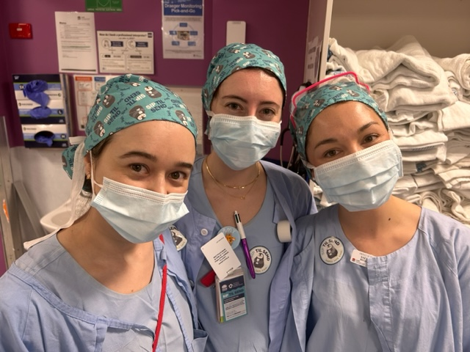

Fabric for scrubs Digital Fabrics https://www.digitalfabrics.com.au/
Stickers and T-shirts Vistaprint https://www.vistaprint.com.au/
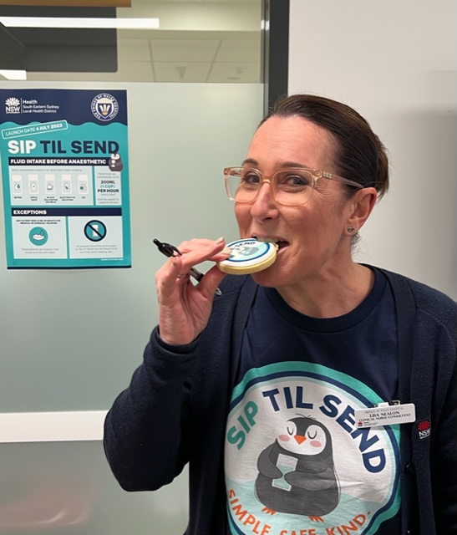
Badges Make Badges https://www.makebadges.com.au/
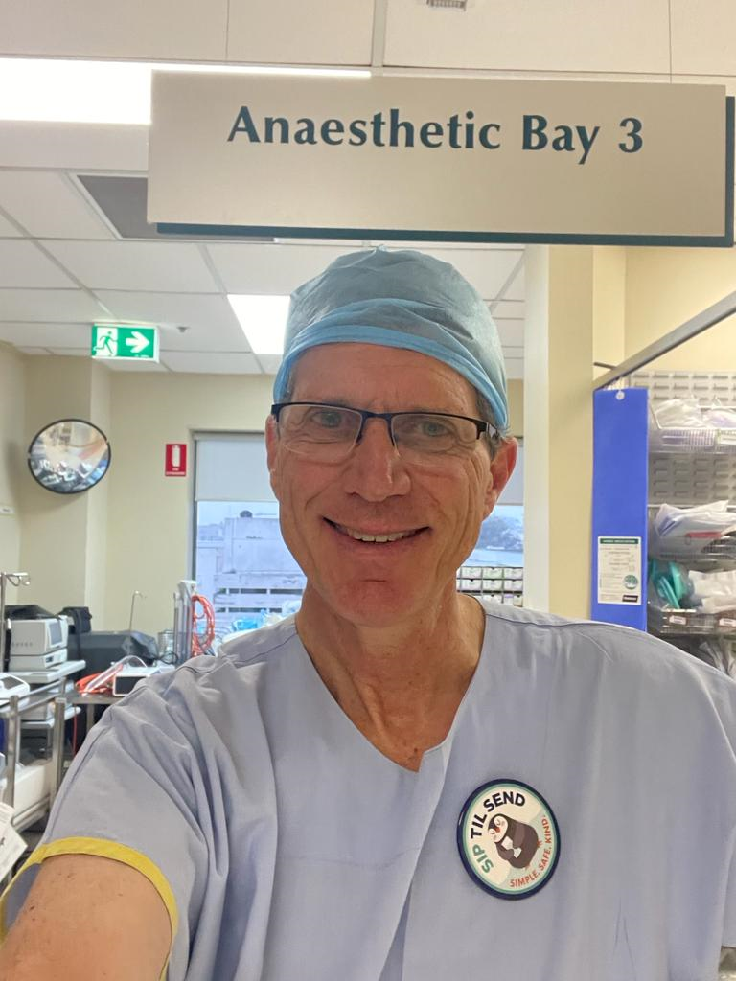
Mugs Gelato/Optimalprint https://www.optimalprint.com.au/
Cookies The Confectionist https://www.theconfectionist.com.au/
