Local Operating Protocol

Title: HIP FRACTURE PATHWAY

Document Control Register Number:
- Summary: A pathway will support optimal patient care and lead to better outcomes for patients
Key Words:
Hip Fracture
Fractured neck of femur
Clinical pathway
Agency for Clinical Innovation (ACI)
Minimum Standards for the Management of Hip Fracture
Fasting Traffic Lights

Facility:

Functional Sub Group: ☐ Clinical ☐ Corporate
☒ New ☐ Replaces:
Endorsement Date:

Publication Date:

Next Review Due: (2 years following publication)
Applies To: Nurses Doctors and Allied health
National Standards that this Protocol Applies To: all
Approved By: General Manager

Version Control and Change History:

Version | Date from | Date to | Amendment
1.0 |  |  | Original Version
2.0
3.0

- Background

Every day, more than 40 Australians break their hip. Most are aged 65years or over, and more than half are aged 85 or over.
Hip fractures are a significant injury in elderly patients, representing a leading cause of morbidity, mortality and loss of function. Poor management of patients with hip fractures can result in medical complications, longer hospital stays and inferior patient outcomes.

The British Orthopaedic Association recommends that “all patients with hip fracture who are medically fit should have surgery within 48 hours of admission, and during normal working hours”. Additional guidelines have also been detailed by the Swedish National Registry of Hip Fracture Patient Care.

The Agency for Clinical Innovation (ACI) has developed the Minimum Standards for the Management of Hip Fracture to assist hospitals in identifying key components of best practice management for hip fractures that will support optimal patient care and lead to better outcomes for patients across New South Wales. The benefits of the Minimum Standards for the Management of Hip Fracture reduce medical complications, reduce hospital stays and improve patient outcomes.

The ACI believes that the implementation of and adherence to evidence-based standards will considerably improve the care and management of older patients with hip fractures in NSW hospitals. Improved care and management of these patients will result in better outcomes, including:
- reduction in morbidity and mortality
- better functional outcomes
- increased discharge rates to original place of residence
- increased value from the health dollar spent

Benefits for Orange Health Service
- Reduced Length of stay in hospital
- Improved patient outcomes
- Less medical complications
- Reduced readmissions due to refracture keeping people in their home environment
- Less fasting times to all surgical patients
- Improved referral to specialist medical services
- Building partnership with general practioners and external providers
- Patients are discharged back to their home
- The patients journey is improved with the introduction of new protocols
- A pathway will support optimal patient care and lead to better outcomes for patients
- Standardised care for all patients across WNSWLHD
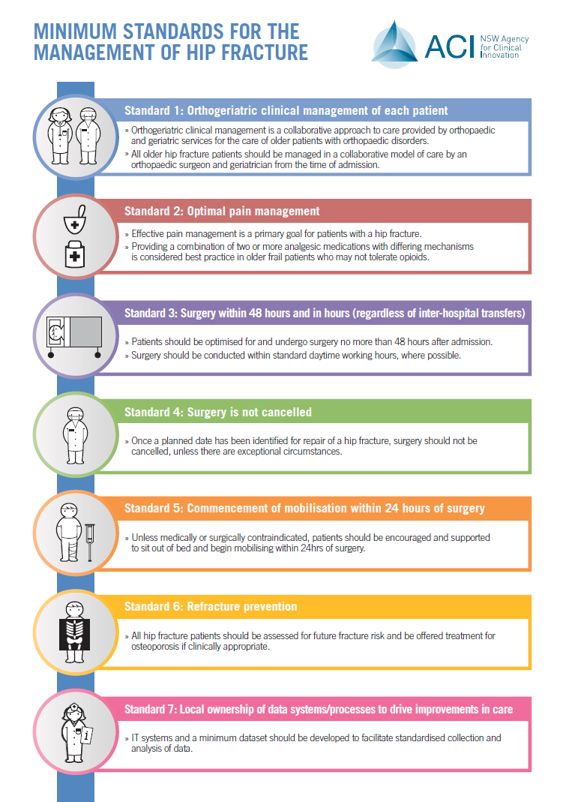

- Process

Patients with a fractured hip are to be IMMEDIATLEY referred to Orthopaedics, Medical, Anaesthetics and Subacute team.
The aim of this Clinical Pathway is to ensure best practice in the care of patients who have a hip fracture.

This pathway is based as much as possible on available evidence and has been developed collaboratively by all the disciplines involved.

Important!!

ALL recommendations apply only in the absence of contraindications

If you’re uncertain, PLEASE discuss with a senior member of your team.

Attached is a treatment guide which is to be followed unless contraindicated (See appendix 1)
This is a treatment guide and DOES NOT replace progress notes and orders.

*

This clinical pathway has been designed with the ACI’s Minimum Standards for the Management of Hip Fractures. These standards can be found at:
http://www.aci.health.nsw.gov.au/resources/aged-health/hip-fracture/min-standards-hip-fractures

Once a patient has an identified hip fracture, this protocol will commence. This will commence either in the emergency department or on the ward.
This will apply to all patients with a fractured hip.
This will apply to all patients who are for inoperable management of a hip fracture.
This will apply to all patients who require surgery for a hip fracture.

Protocol includes (see appendix):
Hip fracture checklist
Discharge proforma
Osteoporosis

Standard 1: Orthogeriatric clinical management of each patient

A Medical assessment of the patient is to occur within 24hrs of admission.
This is to be done by a Medical Consultant or Medical registrar
Patients are to be referred IMMEDIATLEY to the following teams:
- Orthopaedics
- Medical
- Anaesthetics
- Subacute

Standard 2: Optimal Pain management

- Panadol 6hrly
- Femoral nerve block /Fascia iliac Block
- PRN Opiates (Endone, Morphine, Fentanyl)
- NSAIDS are NOT recommended

Standard 3: Surgery within 48 hours and in hours (regardless of inter-hospital transfer)

- Patients should undergo surgery for hip fracture as soon as they have been assessed
as medically stable

Standard 4: Surgery is not cancelled

- Patients are not the fast any longer the 12 hours under any circumstances
- Fasting from midnight is unnecessary
- Clear fluids are to be given up to 2 hours before theatre (water, ice and apple juice)
- IV Fluids if clinically indicated
- If a patient is cancelled they are to be first on the morning list the next day

Standard 5: Commencement of mobilisation within 24hrs of surgery

- Mobilisation should occur within 24hrs of surgery unless contraindicated,
and be repeated at least once a day

Standard 6: Refracture prevention

- Osteoporosis work up and treatment for these patients include:
□ Osteoporosis Pathology
□ Commenced on Vit D
□ Dental Review
□ Bone scan
□ Endocrinology review

Standard 7: Local ownership of data systems/ processes to drive improvements in care
- The hip fracture pathway will be followed unless contraindicated.
- The pathway will be a local operating protocol
- Regular audits will be conducted
- Data will be collected
- EMR2 pathway late 2016

Key Definitions

Hip Fracture: A hip fracture is generally considered to be any fracture of the femur distal to the femoral head and proximal to a level a few centimetres below the lesser trochanter.

Types of Hip Fractures:
- Intra-capsular (within the hip capsule - classically called femoral neck fractures)
- Sub-capital
- Mid-cervical
- Basi-cervical

- Extra-capsular (outside the hip capsule)
- Inter-trochanteric fractures
- Sub-trochanteric fracture
Operations:
- Dynamic Hip Screws (DHS)
- Hemiarthroplasty
- Intramedullary Nail
- Total Hip Replacement (THR)
- Cannulated Screws

Inoperable management:

- Traction
- Conservative management; bed rest

Weight bearing status:

  - Non Weight Bear (NWB)
  - Weight Bear As Tolerated (WBAT)
  - Touch Weight Bear (TWB)
  - Partial Weight Bear (PWB)

The Agency for Clinical Innovation (ACI)
The Agency for Clinical Innovation is the lead agency in NSW for promoting innovation, engaging clinicians and designing and implementing new models of care. All ACI models of care are built on the needs of patients, and are underpinned by extensive research conducted in collaboration with leading researchers, universities and research institutions. Clinical Networks, Taskforces and Institutes provide a forum for doctors, nurses, allied health professionals, managers and consumers to collaborate across the NSW health system.

ACI hip fracture standards:
The Agency for Clinical Innovation (ACI) has developed the Minimum Standards for the Management of Hip Fracture to assist hospitals in identifying key components of best practice management for hip fractures that will support optimal patient care and lead to better outcomes for patients across New South Wales. The benefits of the Minimum Standards for the Management of Hip Fracture reduce medical complications, reduce hospital stays and improve patient outcomes.
Full copy of the standards can be found at:
http://www.aci.health.nsw.gov.au/resources/aged-health/hip-fracture/min-standards-hip-fractures

Fasting traffic lights is an effective tool to help clinical staff to determine periods of fasting.
Orange Health Service Protocol for emergency orthopeadic patients:
http://wnswlhd.gwahs.nswhealth.net/LHDDocumentsAndLinks/FileLink.php?file=2510

Legal and Legislative Framework

This section should describe the legal or legislative context (governmental direction or a recognised external standard) within which the Local Operating Protocol operates.

Risk Statement

This section should describe the risks which will be addressed through the implementation of this Local Operating Protocol, as relevant to the operators of the facility.

Document Retention
Documents listed below must be retained for the deﬁned retention period within the organisation. Corporate Records will let you know how long these documents will need to be retained. (see ‘key points to consider section)

Document Type | Retention Schedule | Retention Period
e.g. Clinical Audit | GDA21-2.2.1 | Destroy after 6 years

References and Links

ACI’s Minimum Standards for the Management of Hip Fractures. These standards can be found at:
http://www.aci.health.nsw.gov.au/resources/aged-health/hip-fracture/min-standards-hip-fractures

The British Orthopaedic Association (BOA) is the Surgical Specialty Association for Trauma and Orthopaedics in the UK http://www.boa.ac.uk/

- Consultation Undertaken

Include all involved in the consultation process (ie List).

Danielle Collison CNS
Dr Darryl Mackender
Dr Michael Stone
Hip fracture project team

Appendix 1

